Connor Johnson Problem Set 3

4.

a)

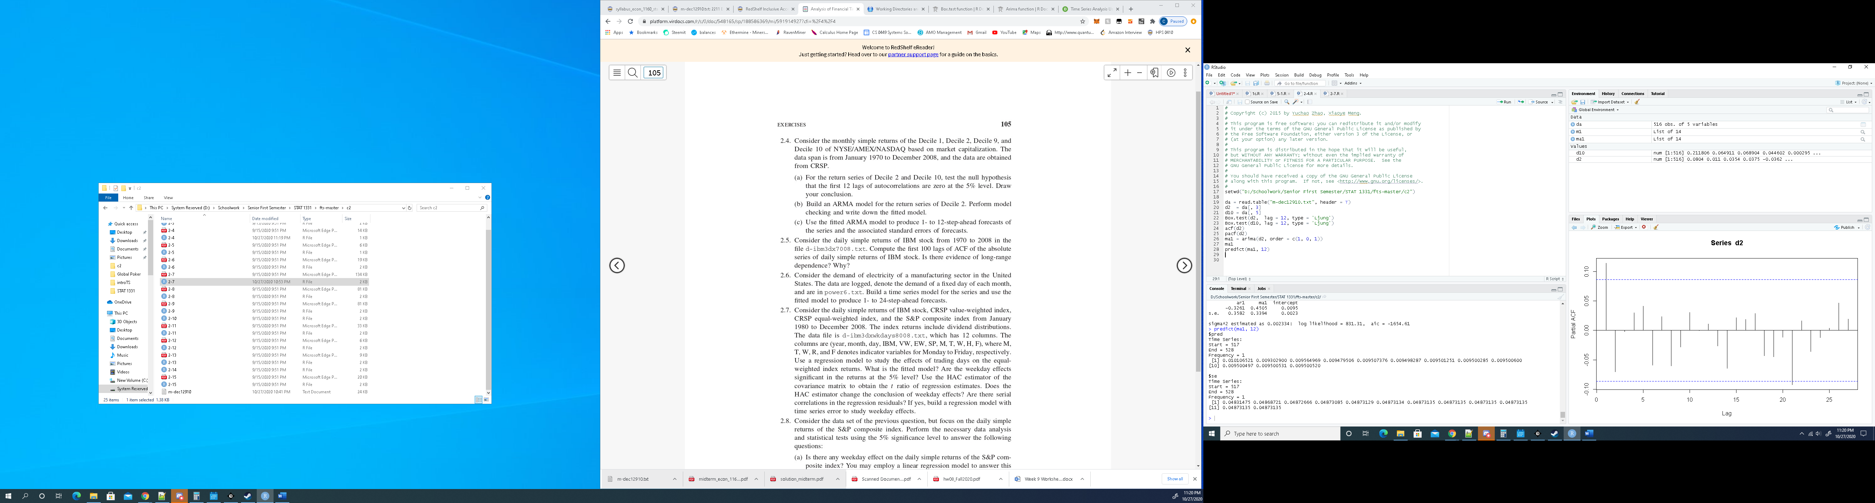

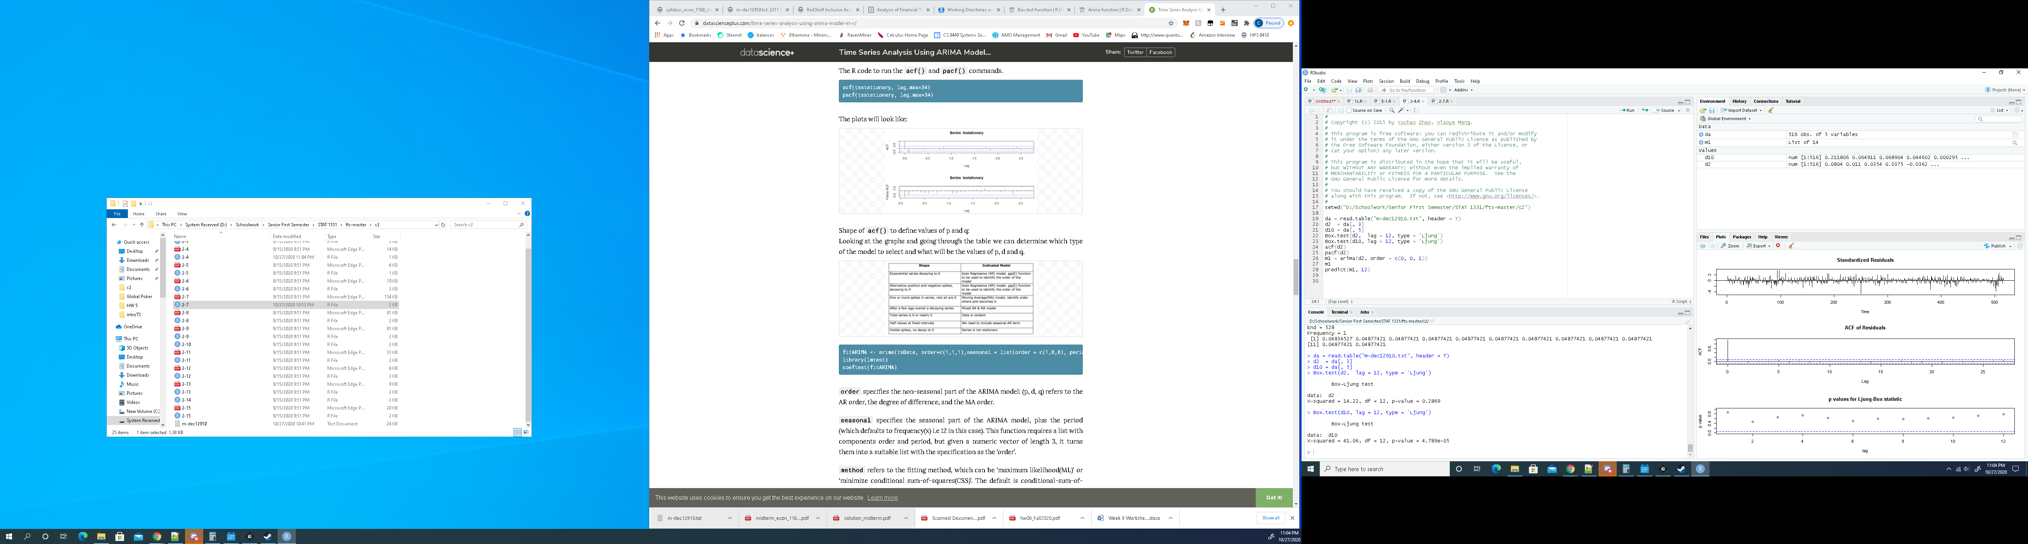

For Decile 2, p > 0.05 so fail to reject the null hypothesis that the first 12 lags of autocorrelation are zero

For Decile 10, p < 0.05 so reject the null hypothesis that the first 12 lags are zero

b)

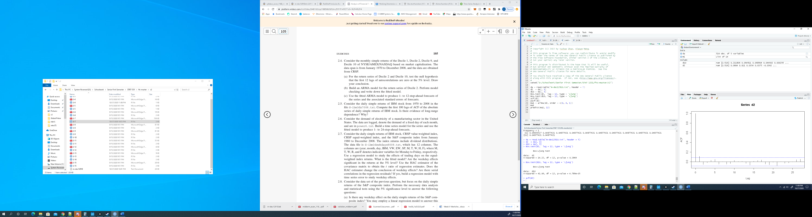



Based on the ACF and PACF plot, the best model is an ARMA(1,1)

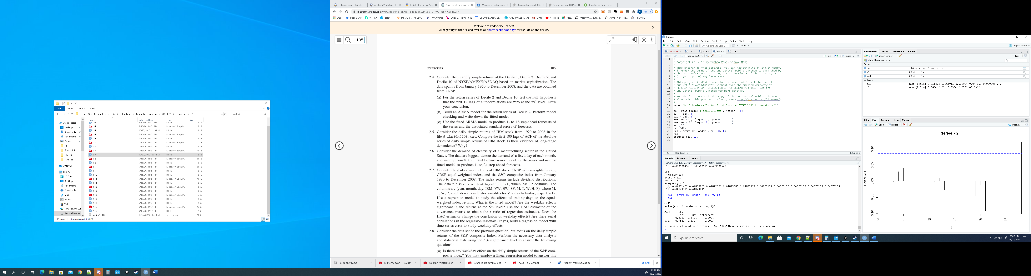

c)

